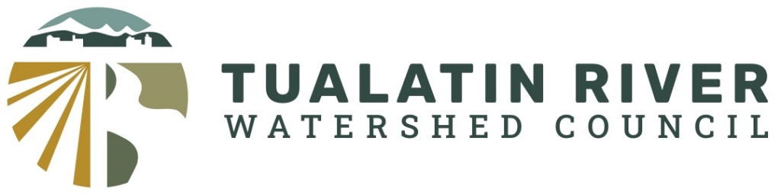
Draft Agenda
September 3, 2025
7:00 – 8:30 pm

1. Meeting Called to Order – Sara Burke Kral
2. Introductions
3. Review and Approval of Agenda – Sara Burke Kral
4. Riparian Restoration and Enhancement Activities of Partner Organization
- Lisa Huntington, Clean Water Services – Natural Systems Enhancement and Stewardship
- Antonella Fillet, Tualatin River Watershed Council – Protecting and Restoration Priority Cold Water Habitat of the Tualatin – Finger and Coffee Creek Projects
- Erik Horngren, Tualatin Riverkeepers Restoration Program
- Lacey Townsend, Tualatin Soil and Water Conservation District – Rural and Urban Enhancement Programs
5. Discussion
- Do barriers exist that limit or prevent coordination
- Do we need public (or private) a watershed based inventory to track restoration/enhancement activities
- Where are the highest unmet needs
  - Ideas on how to improve collaboration

